**P.4 COMPOSITION AND COMPREHENSION LESSON NOTES**

**FOR TERM II**

|  |  |  |  |  |
| --- | --- | --- | --- | --- |
| **Date** | **Class** | **Subject** | **No. of pupils** | **Time** |
|  | **P.4** | **Composition** |  |  |

**Spelling bee**

1. lend
2. borrow
3. behavior
4. obey
5. damage

**TOPIC: Behaviour**

**SUB – TOPIC: Composition**

**SKILLS: Listening, Speaking, Reading, Writing**

**ASPECT: Composition**

**Behaviour** is the way that somebody behaves or conducts especially towards people.

**Vocabulary**

excuse thank sorry forgive

lend borrow please

**Construct sentences using these given words correctly**

1. thank –
2. forgive –
3. lend –

**Fill in the blank spaces using the correct word from the list below.**

excuse, forgive, sorry, thank you, lend , borrow

1. Anatoli told his aunt, “I am ____, I didn’t fetch water for you.”
2. When my father gave me money to buy pancakes, I said _________ you.
3. Would you ____me your umbrella, please? I will return it tomorrow.
4. Bbosa told Kaheru, “may I ____your needle, please?
5. The pupil said, “I am very ____, I forgot to sweep the classroom”
6. “____sir, may I go outside, please?”

|  |  |  |  |  |
| --- | --- | --- | --- | --- |
| **Date** | **Class** | **Subject** | **No. of pupils** | **Time** |
|  | **P.4** | **Composition** |  |  |

**Spelling bee**

1. cheat
2. polite
3. excuse
4. abuse
5. please

**TOPIC: Behaviour**

**SUB – TOPIC:**

**SKILLS: Listening, Speaking, Reading, Writing**

**ASEPCT: Composition**

**Using: “Would you like ……..?**

**Examples:**

1. Travel by boat (no)

**Question**: Would you like to travel by boat?

**Answer**: No, thank you.

1. Some cold water (yes)

**Question**: Would you like to have some cold water?

**Answer**: Yes, please.

**Exercise**

1. Some roasted chicken. (yes)
2. A bottle of soda (yes)
3. Green mangoes (no)
4. A story book ?(no)
5. Some rice (yes)
6. Coloured pencils (yes)
7. a ride on my bicycle (no)
8. Some pancakes (yes)

|  |  |  |  |  |
| --- | --- | --- | --- | --- |
| **Date** | **Class** | **Subject** | **No. of pupils** | **Time** |
|  | **P.4** | **Comprehension** |  |  |

**Spelling bee**

1. sharing
2. may
3. steal
4. unkind
5. burn

**TOPIC: Behaviour**

**SUB – TOPIC:**

**SKILLS: Listening, Speaking, Reading, Writing**

**ASPECT: Comprehension**

**Dialogue:**

A dialogue between Busingye and Amina.

**Read the dialogue and answer the questions that follow.**

Busingye : Hello Amina. I have a problem. Will you help me, please?

Amina : What can I do for you?

Busingye : I lost my pen as I was playing in the field yesterday. May I borrow yours,

please?

Amina : Oh yes! I have two pens. I can lend you one. Here it is.

Busingye : Thank you very much. You are very kind.

Amina : You are welcome. May I know when I can have my pen back?

Busingye : I will return it tomorrow morning.

Amina : I hope you will be careful with it.

**Questions:**

1. Who are taking part in the dialogue?
2. What problem did Busingye have?
3. Why did Busingye borrow Amina’s pen?
4. How many pens did Amina have?
5. When did Busingye promise to return the pen?
6. Write the opposites (i) lend (ii) kind.
7. What do you learn from the dialogue?

|  |  |  |  |  |
| --- | --- | --- | --- | --- |
| **Date** | **Class** | **Subject** | **No. of pupils** | **Time** |
|  | **P.4** | **Composition** |  |  |

**Spelling bee**

1. damage
2. careless
3. dodge
4. disobey
5. forgive
6. lent

**TOPIC: Behaviour**

**SUB – TOPIC:**

**SKILLS: Listening, Speaking, Reading, Writing**

**ASPECT: Composition**

Using: “May I borrow ……….., please?

**Examples:**

1. How would you borrow a pen?

May I borrow a pen, please?

Could I borrow a rubber, please?

1. How would you borrow a bicycle from peter?

May I borrow a bicycle Peter, please?

Could I borrow a bicycle Faith, please?

**Exercise**

1. How would you borrow a wheel barrow from Acom?
2. How would you borrow a ruler from Nankunda?
3. How would you borrow a Koran from Farida?
4. How would you borrow a basket from Sandra?
5. How would you borrow a newspaper from the teacher?
6. How would you borrow an umbrella from Kabagambe?

|  |  |  |  |  |
| --- | --- | --- | --- | --- |
| **Date** | **Class** | **Subject** | **No. of pupils** | **Time** |
|  | **P.4** | **Composition** |  |  |

**Spelling bee**

1. quarrel
2. punish
3. sorry
4. request

**Guided dialogue**

Mortin: Good morning Martha.

Matha: ________________________________________________________________________

Mortin: How are you?

Matha: ________________________________________________________________________

Mortin: Why are you not fine?

Matha: ________________________________________________________________________

Mortin: You don’t have a sharpener! Can I lend you mine?

Matha: ________________________________________________________________________

Mortin: Here it is, but remember to return it. Who stole your sharpener?

Matha: ________________________________________________________________________

Mortin: Mary! Where did she find it?

Matha: ________________________________________________________________________

Mortin: In your Mathematical set! Did you inform your parents?

Matha: ________________________________________________________________________

Mortin: Why didn’t you inform your parents?

Matha: ________________________________________________________________________

Mortin: They would punish you! Take this money and buy your own sharpener.

Matha: ________________________________________________________________________

Mortin: Good bye.

Matha: ________________________________________________________________________

|  |  |  |  |  |
| --- | --- | --- | --- | --- |
| **Date** | **Class** | **Subject** | **No. of pupils** | **Time** |
|  | **P.4** | **Composition** |  |  |

**Spelling bee**

1. ride
2. obedient
3. bird
4. blunt
5. lay

**TOPIC: Behaviour**

**SUB – TOPIC: Bad behaviour**

**SKILLS: Listening, Speaking, Reading, Writing**

**ASPECT: Composition**

**Vocabulary**

rude abuse steal quarrel hate

unkind disobey lie fight bad.

**Write the opposites of these words.**

1. unkind –
2. disobey –
3. hate –
4. bad –

**Choose the right word to complete the sentences.**

1. ______ people care for the sick. (kind, unkind)
2. Kato is ____child; he does what his parents send him. (a disobedient, an obedient)
3. Babirye ___her brothers, she gives them sweets. (loves, hates)
4. ___people are always polite. (rude, humble)
5. Good children ___their parents at home. (help, don’t help)
6. ____behaved children do not greet people. (badly, well)
7. ____pupils do not greet their teachers. (rude, ,polite)
8. Teacher praises ____behaviour. (good, bad)

**Homophones**

Use the words below in sentences to show that you know the meaning

bad and bird

lie and lye

where and were

steal and still

fight and tight

|  |  |  |  |  |
| --- | --- | --- | --- | --- |
| **Date** | **Class** | **Subject** | **No. of pupils** | **Time** |
|  | **P.4** | **Comprehension** |  |  |

**Spelling bee**

1. compare
2. worry
3. steal
4. fight
5. tight

**TOPIC: Behaviour**

**SUB – TOPIC: Poem**

**SKILLS: Listening, Speaking, Reading, Writing**

**Aspect: Comprehension**

**Poem**

**Read the poem and answer the questions about it in full sentences.**

**SORRY**

There is no one in this world

Who does not do wrong.

So, we all do wrong

Every day, every week

We cannot be wrong all the time,

We cannot be right all the time

Sometimes we think wrongly

Other times we act unkindly.

The young say sorry when in the wrong

The old say sorry when in the wrong

Remember to say sorry

Say so and do not worry

You can be forgiven, all the time.

**Questions**

1. What is the poem about?
2. What should one do after doing any wrong.
3. How many stanzas has the poem?
4. When do the young and old say sorry?
5. Do all people do wrong?

|  |  |  |  |  |
| --- | --- | --- | --- | --- |
| **Date** | **Class** | **Subject** | **No. of pupils** | **Time** |
|  | **P.4** | **Composition** |  |  |

**Spelling bee**

1. robbed
2. occurred
3. started
4. realize
5. discipline

**TOPIC: Behaviour**

**SUB – TOPIC: Bad behaviour**

**SKILLS: Listening, Speaking, Reading, Writing**

**ASPECT: Composition**

Using: “..................must ...............”

**Examples:**

1. You should not spoil school property

You must not spoil school property

1. You should not write on the wall

You must not write on the wall

1. You should not play in the classroom.

You must not play in the classroom.

**Exercise**

**Re-write the given sentences using ..........must not ...........**

1. You should not fight.
2. You should not be unkind to animals.
3. You should not be careless with your property.
4. You should not come late to school.
5. You should not abuse people.
6. You should not laugh at lame people.
7. You should not shout in class.

|  |  |  |  |  |
| --- | --- | --- | --- | --- |
| **Date** | **Class** | **Subject** | **No. of pupils** | **Time** |
|  | **P.4** | **Composition** |  |  |

**Spelling bee**

1. accident
2. concern
3. response
4. helping
5. treatment

**Topic : Behaviour**

**Jumbled composition**

**Re-arrange the jumbled sentences below to form a correct story**

1. on his way to school, he was knocked by a speeding vehicle.
2. He quickly organized himself and rushed to school.
3. One day, he woke up in the morning and realized that he was late for school.
4. Juma is a boy in P.4 class.
5. Juma’s friends heard about what happened to him and went to check on him in the hospital.
6. The nurses later informed Juma’s teachers about what had happened to their pupil.
7. Peter, Juma;s best friend went and informed Juma’s parents about Juma.
8. Later, Juma became well and was brought back home.
9. Juma’s parents rushed to the hospital to see Juma.
10. Lucky enough, the driver had mercy on him and took him to the hospital.

|  |  |  |  |  |
| --- | --- | --- | --- | --- |
| **Date** | **Class** | **Subject** | **No. of pupils** | **Time** |
|  | **P.4** | **Composition** |  |  |

**Spelling bee**

1. arrive
2. arrival
3. time
4. warning
5. apologize

**TOPIC: Behaviour**

**SUB – TOPIC: Bad behaviour**

**SKILLS: Listening, Speaking, Reading, Writing**

**ASPECT: Composition**

**Guided composition**

**Complete the composition using the list of words below.**

sorry respect abuse greets well

forgot mistake primary

**The obedient boy**

Mulisa is about ten years old. He is a pupil in Primary Four at Katende _______School. Muliisa is a ________ behaved boy. He __________his mother and father every morning. Then he goes to school.

Muliisa doesn’t like pupils who __________teachers.

He likes those who ______their teachers. When Muliisa makes a ___________, he apologizes to the teacher by saying, “I am __________, teacher.”

|  |  |  |  |  |
| --- | --- | --- | --- | --- |
| **Date** | **Class** | **Subject** | **No. of pupils** | **Time** |
|  | **P.4** | **Composition** |  |  |

**Spelling bee**

1. compare
2. interpret
3. observe
4. helping
5. cleaning

**PICTURE COMPOSITION**

Study the pictures below carefully.

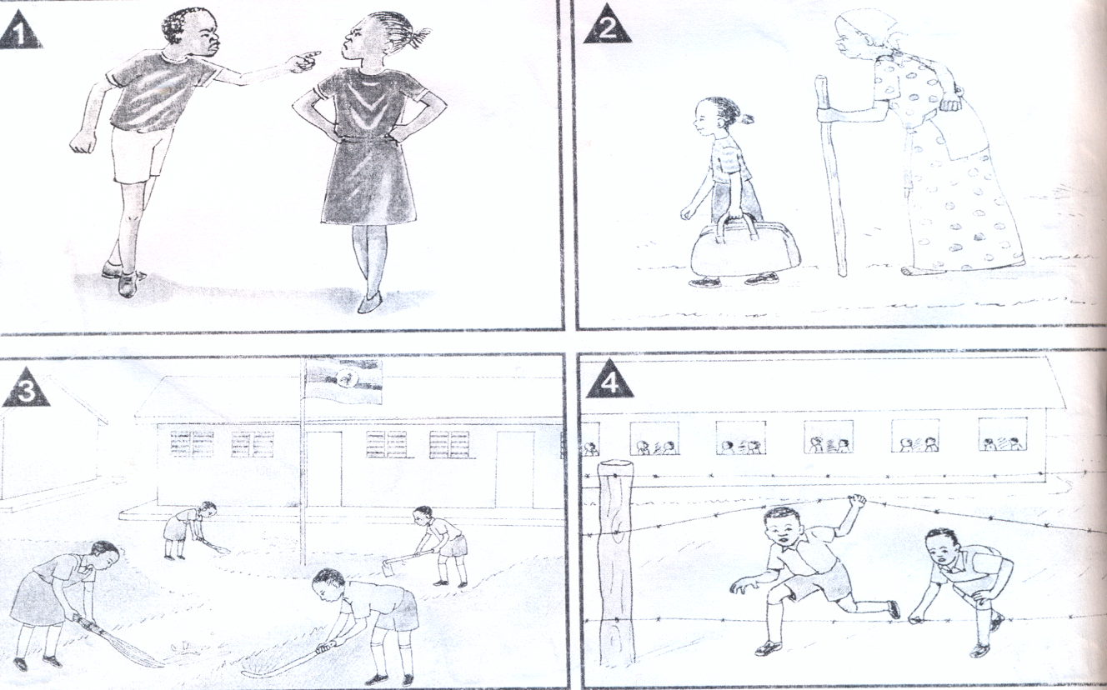

**What behaviour is shown in the pictures above**

Picture 1:

Picture 2:

Picture 3:

Picture 4:

**Lesson**

The most disciplined child in our class.

* How many children are in your class?
* What is his name?
* How does he behave?
* How do teachers and other pupils comment about his behaviour?

|  |  |  |  |  |
| --- | --- | --- | --- | --- |
| **Date** | **Class** | **Subject** | **No. of pupils** | **Time** |
|  | **P.4** | **Composition** |  |  |

**Spelling bee**

1. undiscipline
2. buck
3. duck
4. price
5. cheap

**Topic: Behaviour**

**Composition writing**

**My Humble Sister**

Point to note

* her name
* school
* class
* what she likes
* behavior

|  |  |  |  |  |
| --- | --- | --- | --- | --- |
| **Date** | **Class** | **Subject** | **No. of pupils** | **Time** |
|  | **P.4** | **Comprehension** |  |  |

**Spelling bee**

1. expensive
2. departing
3. depart
4. departure
5. shopping

**TOPIC: Behaviour**

**SUB – TOPIC:**

**SKILLS: Listening, Speaking, Reading, Writing**

**ASPECT: Comprehension**

**Passage**

**Read the passage carefully and answer the questions that follow in full sentences.**

**Baluku’s Sugar canes / Tom’s Evening**

Mr Baluku lived in Semliki Village. He had a big sugar cane plantation. Many pupils from Semliki Academy went to his home because they wanted sugar canes.

One day, Harriet went to Mr. Baluku. She wanted a sugar cane from him. “Give me a sugarcane,” she said

“No, I will not give you any sugar cane. You are not a polite girl. Go away!” Baluku said.

Harriet wondered why Mr. Baluku did not want to give her any sugar cane. “I haven’t done anything wrong,” Harriet said. She decided to talk to her friend Banya about it.

“Mr. Baluku refused to give me a sugar cane,” she told Banya. “He said that I was impolite.”

C:\Users\user\Desktop\SCANNED IMAGES\scan0009.tif“What did you do?” asked Banya. “I didn’t do anything bad. I asked him to give me only one sugarcane,” Harriet explained.

Banya laughed at Harriet and asked, “Did you greet him?”

“No. I didn’t greet him. I think that is why he refused to

give me a sugar cane,” said Harriet.“Why don’t you go back to him?

You should remember to greet him humbly before you ask him

for his sugar canes. No one eats Mr. Baluku’s sugar canes before greeting him!”

Harriet ran back to Mr. Baluku. She greeted him humbly. Mr. Baluku was very happy this time. He gave Harriet a big sugar cane. Harriet was very happy. “Thank you very much, Mr Bakuku,” she said.

“You are welcome,” Mr. Baluku answered . “You should always be polite. I like polite children. Now you are a good girl.”

**Questions**

1. Where did Mr. Baluku live?
2. Why did many pupils go to Mr. Baluku’s home?
3. In which school was Harriet?
4. What shows that Harriet was not polite?
5. Was Harriet standing when she greeted Mr. Baluku?
6. What did Harriet say to Mr. Baluku after he had given her a Sugarcane?
7. What did Mr. Baluku say to Harriet when she thanked him for the sugarcane?
8. What kind of children does Mr. Baluku like?
9. Write the opposite of
10. happy
11. obedient

|  |  |  |  |  |
| --- | --- | --- | --- | --- |
| **Date** | **Class** | **Subject** | **No. of pupils** | **Time** |
|  | **P.4** | **Composition** |  |  |

**Spelling bee**

1. beef
2. mutton
3. veal
4. steak
5. chicken

**TOPIC: SHOPPING**

**SUB – TOPIC:**

**SKILLS: Listening, Speaking, Reading, Writing**

**ASPECT: Composition**

**Vocabulary**

some a few expensive price money change

any cheap cost item enough balance

**Construct sentences using these given words below**

1. money
2. some
3. price
4. cheap

**Use the words given in the list to complete the sentences**

money, price, sells, enough, any

1. There isn’t _____money in the bag.
2. The ___of petrol is written on the board.
3. I don’t have ___money to buy a pen.
4. The shopkeeper ____goods in a shop..
5. Jane has lost her ____.

**Give the opposite**

1. cheap
2. borrow
3. sell
4. high

**Write in full**

1. shs.
2. Cr.
3. @

|  |  |  |  |  |
| --- | --- | --- | --- | --- |
| **Date** | **Class** | **Subject** | **No. of pupils** | **Time** |
|  | **P.4** | **Composition** |  |  |

**Spelling bee**

1. cost
2. shillings
3. balance
4. change
5. kilogramme

**TOPIC: SHOPPING**

**SUB – TOPIC:**

**SKILLS: Listening, Speaking, Reading, Writing**

**ASPECT: Composition**

**Structures**

**Using: “How much is …..?”**

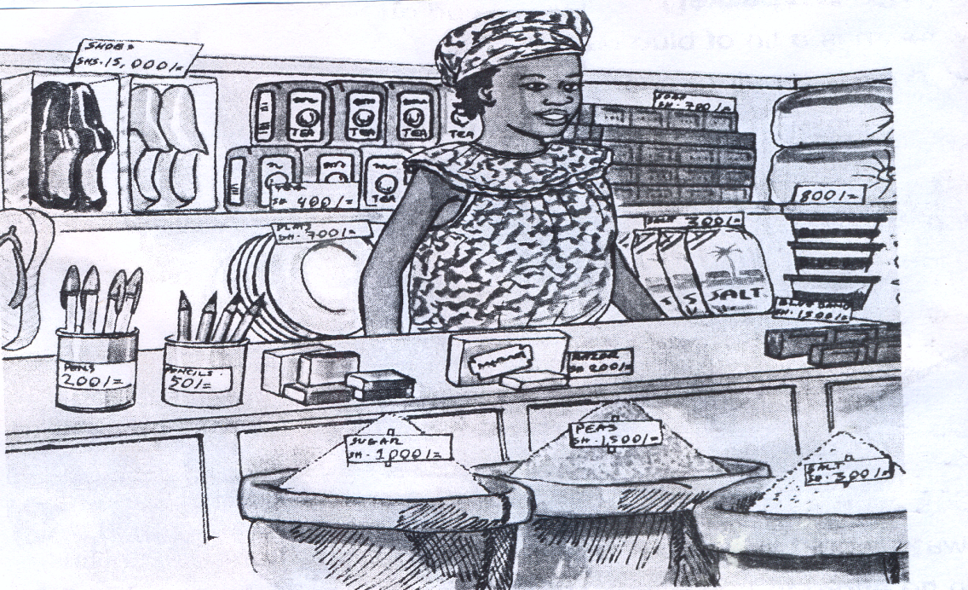This is Fatuma’s shop. Answer the questions that follow.

**Examples**

1. How much is a pen?

A pen is two hundred shillings.

1. How much is one kilogram of sugar?

One kilogram of sugar is one thousand shillings.

**Draw a table showing items and the prices**

|  |  |
| --- | --- |
| plate | 300/= |
| sugar | 1000/= |
| pens | 200/= |
| soap | 400/= |

**Exercise**

**Study the items in the shop and their prices and answer the following questions.**

1. How much is a kilogram of salt?
2. How much is a kilogram of peas?
3. How much is a packet of tea leaves?
4. How much is a pair of slippers?
5. How much is a plate?
6. How much is a bar of soap?
7. How much is a loaf of bread?
8. How much is a packet of salt?
9. How much is a tin of blue band?
10. How much is a pair of shoes?

|  |  |  |  |  |
| --- | --- | --- | --- | --- |
| **Date** | **Class** | **Subject** | **No. of pupils** | **Time** |
|  | **P.4** | **Comprehension** |  |  |

**Spelling bee**

1. rectangular
2. oval
3. triangular
4. round
5. heavy

**TOPIC: Shopping**

**SUB – TOPIC:**

**SKILLS: Listening, Speaking, Reading, Writing**

**ASPECT: Comprehension**

**Read the dialogue carefully and answer the questions that follow in full sentences**

**A Friend in Need**

Fiona : What are you doing here? You should be revising your books

Magezi : I am waiting for a friend. He told me to meet him here.

Fiona : You look tired. Why don’t you have a soda as you wait?

Magezi : I don’t have enough money to buy anything.

Fiona : How much money do you have?

Magezi : Fifty shillings only.

Fiona : What can you buy with fifty shillings?

Magezi : I can only buy a sweet with fifty shillings. Can you lend me some money?

Fiona : Here is one thousand shillings. It is enough to buy a soda.

Magezi : Thank you very much.

Fiona : You are welcome.

**Questions**

1. Who are the two people in the dialogue?
2. Who looked to be tired?
3. Where was Magezi?
4. How much money did Fiona give to Magezi?
5. How much money did Magezi have?
6. What is the title of the dialogue?

|  |  |  |  |  |
| --- | --- | --- | --- | --- |
| **Date** | **Class** | **Subject** | **No. of pupils** | **Time** |
|  | **P.4** | **Composition** |  |  |

**Spelling bee**

1. beautiful
2. smart
3. cruel
4. ugly
5. rough

**TOPIC: Shopping**

**SUB – TOPIC:**

**SKILLS: Listening, Speaking, Reading, Writing**

**Using: “…enough to ….”**

**Examples:**

1. I have money. I can buy a car.

I have enough money to buy a car.

1. She has money. She can land some to Nambi.

She has enough money to lend some to Nambi.

1. I have little money. I cannot buy a rubber.

I do not have enough money to buy a rubber.

1. Kyalimpa has little money. She cannot buy a loaf of bread.

Kyalimpa does not have enough money to buy a loaf of bread.

**Exercise**

1. Mrs. Ddungu has money. She can pay the workers.
2. They saved money. They can buy a house.
3. Mother has money. She can buy a kilogram of sugar.
4. Monica has money. She can buy a kilogram of sugar.
5. Tumisiime has money. He can buy the car.
6. Uncle Waibi has little money. He cannot give me pocket – money.
7. Aunt Juliet has little money. She cannot buy a hand bag.
8. My parents have little money. They cannot pay my school fees.
9. Susan has little money. She cannot spend any.
10. Arigye has little money. She cannot travel by taxi.

|  |  |  |  |  |
| --- | --- | --- | --- | --- |
| **Date** | **Class** | **Subject** | **No. of pupils** | **Time** |
|  | **P.4** | **Composition** |  |  |

**Spelling bee**

1. junction
2. behind
3. corner
4. signpost
5. close

**TOPIC: Shopping**

**SUB – TOPIC:**

**SKILLS: Listening, Speaking, Reading, Writing**

**ASPECT: Composition**

**Guided Composition**

**SCHOOL FEES**

**Choose the correct word in the box to fill in the blank spaces.**

**happy, shillings, borrowing, fees, lent, any**

One day, I was sent home for _______. It was time for examinations. Father was away on safari. Mother did not have ___money at home. She said she needed five thousand ____only. The shopkeeper ___her the money and asked her to pay it soon.

Mother gave me the money and I ran back to school. I paid the money to the bursar who gave me a receipt. I was very ___to be with my friends once again and write the exams.

|  |  |  |  |  |
| --- | --- | --- | --- | --- |
| **Date** | **Class** | **Subject** | **No. of pupils** | **Time** |
|  | **P.4** | **Composition** |  |  |

**Spelling bee**

|  |  |
| --- | --- |
| **Singular** | **Plural** |
| Negro | Negroes |
| Volcano | ___________________ |
| Hero | ___________________ |
| Echo | ___________________ |
| Mango | ___________________ |

**Topic: Shopping**

**Re-arrange the jumbled sentence about shopping**

Wrong order

1. on his way to the market, he met a group of boys who were going for a comedy show.
2. Each one paid three thousand shillings for entering.
3. John realized that he was late for home and hurried out immediately
4. The boys kept on telling him how nice the comedy was going to be and asked him to join them.
5. John’s mother was so angry that she beat John terribly
6. So she gave him five thousand shillings.
7. He asked his mother which vegetables he was to buy.
8. John picked the shopping bag and went to the market.
9. John was sent by his mother to the marked to buy vegetables.
10. John’s mother wanted cabbages, onions, nakati and some tomatoes.

|  |  |  |  |  |
| --- | --- | --- | --- | --- |
| **Date** | **Class** | **Subject** | **No. of pupils** | **Time** |
|  | **P.4** | **Comprehension** |  |  |

**Spelling bee**

1. print
2. mint
3. central
4. manage
5. colour

**TOPIC: Shopping**

**SUB – TOPIC:**

**SKILLS: Listening, Speaking, Reading, Writing**

**ASPECT: Comprehension**

**Passage**

**Read the passage carefully and answer the questions about it.**

**BANKS**

Uganda has a Central Bank and Commercial Banks. Bank of Uganda (B.O.U) is the Central bank. Other banks like Orient Bank, Nile Bank, Standard Chartered Bank, Tropical Bank, Stanbic , Bank of Baroda, Barclays Bank and Centenary Bank are called Commercial Banks.

The Central Bank makes sure that there are enough bank notes and coins in a country. The Central Bank asks foreign companies to print money for the country. A factory where money is made is called a mint. The Central Bank also withdraws old bank notes from the commercial banks. The Central Bank can lend money to Commercial Banks when they do not have enough money.

Some people, school, companies and ministries keep money in Commercial Banks. We can also keep other valuables like gold or diamond rings, chains in Commercial Banks. Wills and land titles can also be kept safely there. When we are in need of money to develop our home areas, to build schools or industries, we can borrow money from Commercial Banks. Borrowed money is called a loan.

**Questions**

1. What is another name for the Central Bank of Uganda?
2. Write two names of Commercial Banks in Uganda.
3. Write any one use of a Central Bank.
4. What does the Central Bank do with old bank notes?
5. What is a mint?
6. Give one reason why we need money.
7. What is a loan?
8. Write examples of valuable items in the passage.
9. Why must we keep valuable items in the bank?
10. When should schools borrow money from a bank?

|  |  |  |  |  |
| --- | --- | --- | --- | --- |
| **Date** | **Class** | **Subject** | **No. of pupils** | **Time** |
|  | **P.4** | **Composition** |  |  |

**Spelling bee**

1. each
2. per
3. value
4. worry
5. scared

**TOPIC: Shopping**

**SUB – TOPIC:**

**SKILLS: Listening, Speaking, Reading, Writing**

**Make a shopping bill and answer question about it.**

**Study John’s shopping list and answer questions about it.**

|  |  |  |  |
| --- | --- | --- | --- |
| **Item** | **Quantity** | **Cost** |  |
| Rice  Meat  Cassava  Bread  Cooking Oil | 2kg  1kg  3kg  1loaf  1 tin | 1000@  8000@  4000@  1800@  4000@ | Shs. 2000  Shs. 8000  Shs.12000  Shs.18000  Shs. 4000 |

**Questions**

1. How much money did John pay for meat?
2. How many kilograms of cassava did he buy?
3. How much did John pay altogether?
4. What item did John buy Shs. 4000?
5. How many kilograms of rice did John buy?
6. How much did John pay for one kilogram of cassava?
7. Whose shopping list is shown above?
8. How many items did John buy?
9. How many tins of cooking oil did John buy?

**Write kg in full.**

1. kg
2. shs.

|  |  |  |  |  |
| --- | --- | --- | --- | --- |
| **Date** | **Class** | **Subject** | **No. of pupils** | **Time** |
|  | **P.4** | **Composition** |  |  |

**Spelling bee**

1. hold
2. swing
3. bite
4. hide
5. tired

**TOPIC: Shopping**

**SUB – TOPIC:**

**SKILLS: Listening, Speaking, Reading, Writing**

**ASPECT: Composition**

**Picture Composition**

**Study the pictures and answer the questions about it.**

**Why a Bank is Useful**

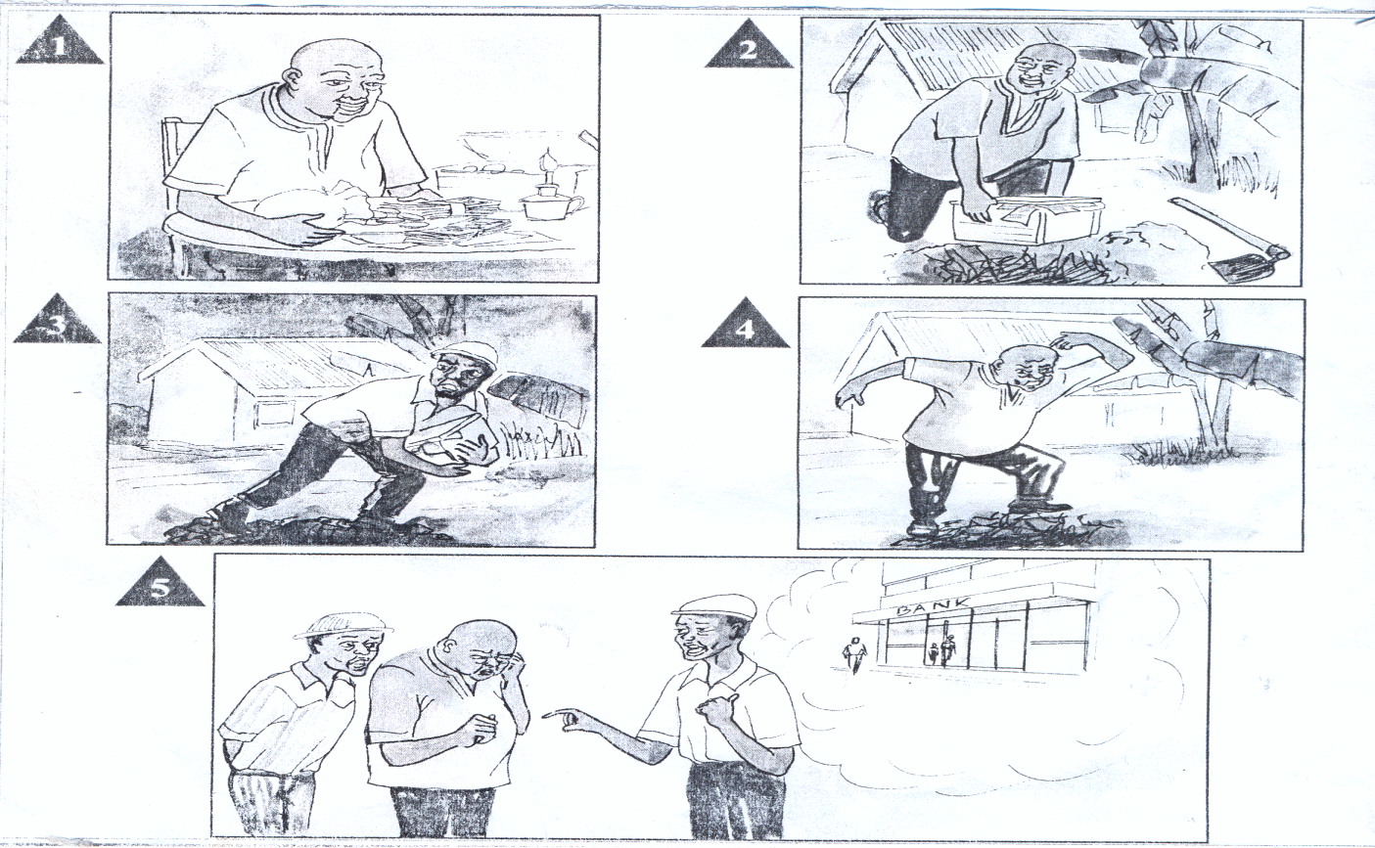

**Questions:**

1. Picture 1:
2. Picture 2:
3. Picture 3:
4. Picture 4:
5. Picture 5:

**Write a short story about “shopping**

1. Tell us what you bought.
2. Who gave you the money
3. Where did you buy it
4. Did you like it?

Write a short story about “My First time to the market”

In the story include the date, place, who sent you, what you bought, how much you spent and how you felt after the shopping

|  |  |  |  |  |
| --- | --- | --- | --- | --- |
| **Date** | **Class** | **Subject** | **No. of pupils** | **Time** |
|  | **P.4** | **Composition** |  |  |

**Spelling bee**

1. loaves
2. halves
3. thieves
4. scarves
5. leaves

**TOPIC: TIME**

**SUB – TOPIC:**

**SKILLS: Listening, Speaking, Reading, Writing**

**ASPECT: Composition**

**Vocabulary of time**

morning, break time, afternoon, evening, night, yesterday, continue

**Make sentences using these words correctly.**

Complete the sentences using the words in brackets correctly

1. Pupils always …………………to school in the morning. (to go)
2. Jackson ……………………..the class during break time. (sweep)
3. I will ………………….water in the evening. (fetch)
4. The dog …………………….loudly last night. (bark)
5. The boys …………………playing football although it was raining. (continue)
6. The girls had……………….the main hall in the afternoon. (clean)
7. I ………………my nephew yesterday. (visit)
8. My father………………back home at night every day. (come)

|  |  |  |  |  |
| --- | --- | --- | --- | --- |
| **Date** | **Class** | **Subject** | **No. of pupils** | **Time** |
|  | **P.4** | **Composition** |  |  |

**Spelling bee**

1. children
2. men
3. oxen
4. mice
5. lice

**TOPIC: TIME**

**SUB – TOPIC:**

**SKILLS: Listening, Speaking, Reading, Writing**

**Structure:**

**Using: “While , When , As”**

These structures are used to show two things happening at the same time.

1. They can begin a sentence. When they begin, a comma is applied immediately after the first sentence.
2. No comma is required if they are put in the middle.

**Examples:**

1. I was taking breakfast. The visitor arrived.

While I was taking breakfast, the visitor arrived.

When I was taking breakfast, the visitor arrived.

As I was taking breakfast, the visitor arrived.

The visitor arrived while I was taking breakfast.

1. Maria was going to the shop at night. She met a wizard.

Maria met a wizard while she was going to the shop at night.

Maria met a wizard as she was going to the shop at night.

Maria met a wizard as she was going to the shop at night.

**Exercise:**

**Join these sentences using: “While, When, as”**

1. Peters takes medicine. Peter has a stomach ache.
2. I was going to school. I met a mad man.
3. Katogo was eating fish. A bone chocked him.
4. MY mother was going to the garden in the morning. A wasp stung her.
5. The nurse was injecting the patient. The syringe broke into two pieces.
6. Teacher was laughing. A fly flew into her mouth.
7. Our grandmother was telling us a story last night. She fell asleep
8. Kalevu was shaving my hair. The electricity went off.
9. My brother was mopping the house. My sister was washing utensils.
10. Mum was cooking food. The visitor arrived from the village
11. The lady was going to the market. A taxi knocked her down.

|  |  |  |  |  |
| --- | --- | --- | --- | --- |
| **Date** | **Class** | **Subject** | **No. of pupils** | **Time** |
|  | **P.4** | **Comprehension** |  |  |

**Spelling bee**

1. knives
2. wives
3. lives
4. reefs
5. safes

**TOPIC: TIME**

**SUB – TOPIC:**

**SKILLS: Listening, Speaking, Reading, Writing**

**ASPECT: Comprehension**

**Calendar**

Read the calendar and answer the questions that follow in full sentences.

**March 2013**

|  |  |  |  |  |  |  |
| --- | --- | --- | --- | --- | --- | --- |
| Sunday |  |  | 4 | 11 | 18 | 25 |
| Monday |  |  | 5 | 12 | 19 | 26 |
| Tuesday |  |  | 6 | 13 | 20 | 27 |
| Wednesday |  |  | 7 | 14 | 21 | 28 |
| Thursday |  | 1 | 8 | 15 | 22 | 29 |
| Friday |  | 2 | 9 | 16 | 23 | 30 |
| Saturday |  | 3 | 10 | 17 | 24 | 31 |

**Questions**

1. Which day is eleventh March, 2013?
2. How many days does this month have?
3. On which day does the month of March begin?
4. How many Sundays are there in this month?
5. On which day does this month end?
6. What is the fifteenth day of the month?
7. What is the thirtieth day of the week?
8. If Peter wanted to visit his uncle on 17th , which day would it be?
9. How many days did children go to school this month?
10. Why is 8th March shaded?

|  |  |  |  |  |
| --- | --- | --- | --- | --- |
| **Date** | **Class** | **Subject** | **No. of pupils** | **Time** |
|  | **P.4** | **Comprehension** |  |  |

**Spelling bee**

1. tell
2. face
3. clock
4. watch
5. half
6. quarter

**Study the pictures below and answer the questions about it**

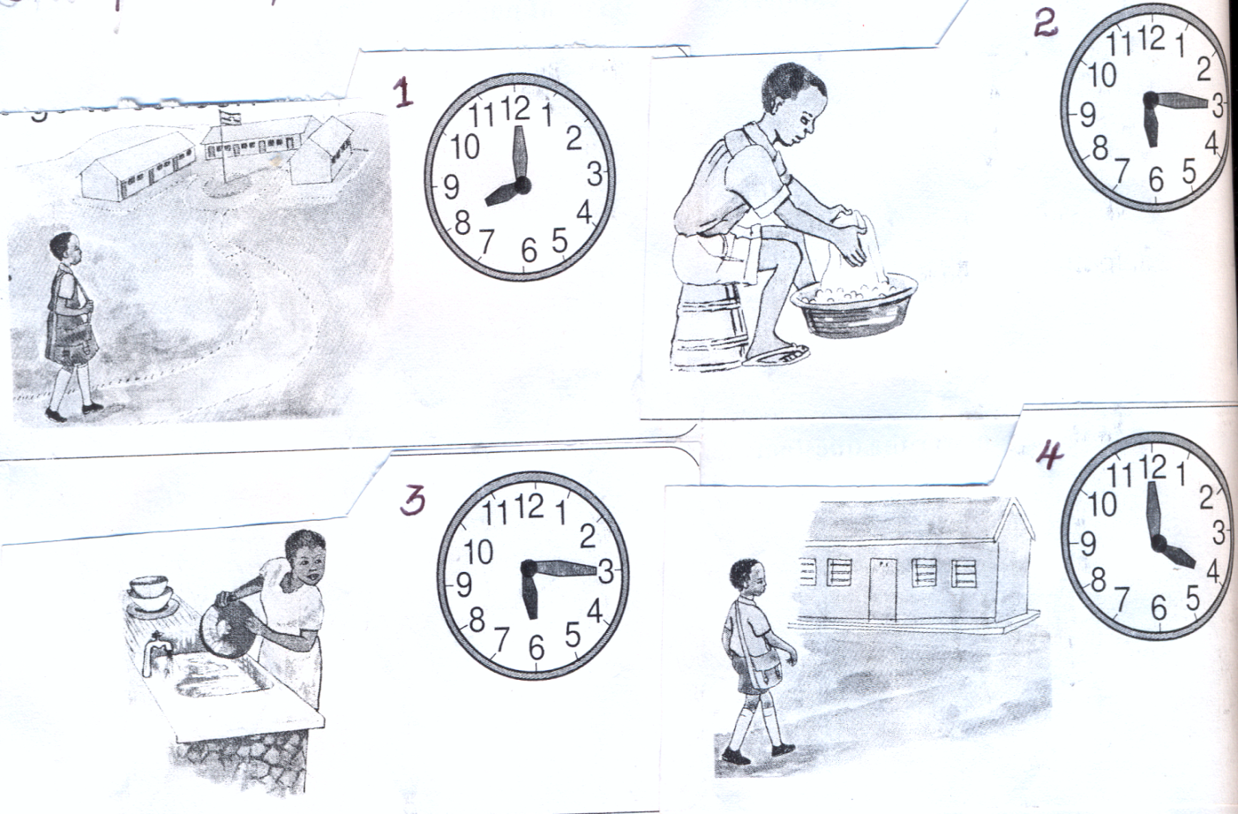

Tell the time each activity is done in the pictures above

Picture 1: (goes to school)

Picture 2: (washes clothes)

Picture 3: (goes back home)

Picture 4: (washes plates)

**Answer these questions:**

1. What is Mary doing in picture 1?
2. In which picture is the boy washing clothes?
3. Where do you think John is going in picture 4?
4. Do you help your parents with work at home?

|  |  |  |  |  |
| --- | --- | --- | --- | --- |
| **Date** | **Class** | **Subject** | **No. of pupils** | **Time** |
|  | **P.4** | **Comprehension** |  |  |

**Spelling bee**

1. staffs
2. gulfs
3. dwarfs
4. proofs
5. chiets

**Lesson**

**Organize a jumbled composition about time**

**Arrange these sentences to make a good composition**

1. We found when the Imam had started preaching.
2. I decided to play with my friend at the well.
3. On Friday after breakfast,
4. Finally she told me to bathe and we went for prayers.
5. After playing, I carried water up to home.
6. I got a jerrycan and hurried to fetch water from the well.
7. Mummy told me to prepare for Juma prayers.
8. Because I delayed at the well
9. When I reached the well, I found many boys playing football.
10. When I reached home, mummy was already annoyed.

**REVISION WORK**

**Using: ….is/ are ……….than ……..**

**Examples:**

1. A pencil is cheap. A pen is cheaper.

A pen is cheaper than a pencil.

1. Beans are expensive. Rice is more expensive

Rice is more expensive than beans.

**Exercise**

1. A shirt is cheap. A short is cheaper.
2. A cake is lighter. Bread is light.
3. This boy is heavy. This girl is very heavy.
4. Rice costs 200/= . Beans cost 300/=
5. Dolls are cheaper. Toy cars are cheap.
6. A litre of milk is expensive. A litre of petrol is very expensive.
7. A car is expensive. An aeroplane is more expensive.

**Poem**

**Read the poem and answer the questions that follow in full sentences.**

I want to know about a calendar

The time and a lot more

The clock tells me time

The watch tells me time

The crowing cock tells me the time too!

The clock ticks at midnight

In the middle of the night

That marks the beginning of the day

Tick tock, tick tock, tick tock

In the middle of the night .

I tell the time

In seconds minutes and hours

The calendar teaches you and me

All days and months of the year

The clock tick – tocks, tick – tocks

All day long and for many long years.

**Questions**

1. What does the writer want to know?
2. Name three things that tell the writer time.
3. What tick- tocks to the writer?
4. How many stanzas has the poem?
5. What tells the writer days and months of the year?

**Using: …because …..**

**Examples**

1. I go to school early in the morning. I don’t want to reach late.
2. I go to school early in the morning because I do not want to reach late.

**Exercise**

**Join these sentences using …….because ……………**

1. I went to the market in the morning. I wanted to buy fresh vegetable.
2. I did not go out at night. I fear night dancers.
3. Peter washes his hands after visiting toilet. He wants to avoid germs.
4. James did not eat lunch. He was having a stomachache.
5. The teacher came late at school. His motorcycle broke down.
6. The chef did not prepare lunch. There was no firewood.
7. James spent a lot of time chewing the meat. The meat was not well cooked. 6